****

**9th Annual Respiratory Nursing Conference**

Thursday 24th and Friday 25th March 2022

(NMBI Category 1 approved for 6 CEUs)

Thursday 24th March 2022

Members Networking Dinner at 7.30pm in The Strand Hotel, Limerick City

Friday 25th March 2022

Conference- The Shannon Suite, The Strand Hotel, Limerick City

Please note there may be some minor changes made to the aganda. Any updates wil be posted on Anáil.ie

|  |  |  |
| --- | --- | --- |
|  | **Topic** | **Speaker** |
| 08.45 | Conference check in opens | Please visit our sponsors in Shannon Suite 1 |
| 09.15-09.20 | Opening Address | Aoife Folliard,  Anáil Chairperson |
| 09.20-10.20 | ENT/Rhinology Update | Dr Mona Thornton,  Consultant Otolaryngologist, RVEEH, Dublin  Helen Mulryan ,  cANP, Galway University Hospitals |
| **10.20-11.00** | **Break – 40 mins Please visits our sponsors in Shannon Suite 1** | |
| 11.00- 11.45 | Anáil Members Meeting  Co-Committee Election  Education Officer Plan | Anáil Committee and Members |
| 11.45-12.05 | Presentations from 2022 Anáil Educational Bursary Recipients | ALK- Abello Bursary- Lisa Egan  Anáil Education Bursaries-  1. Karolina Glomba  2. GUH Respiratory Nurse Service  3. Ruth Kelly |
| 12.05- 12.55 | Nursing Research: Inception to Publication | Dr Mary McDonnell Naughton,  Senior Lecturer, Dept Nursing & Healthcare Technological University of the Shannon: Midlands Midwest |
| **12.55-13.55** | **Lunch – 1 hour** | |
| 14.00-15.00 | Resilience in Challenging Times | Sheila O’Malley,  Professional Trainer |
| 15.00-16.00 | Anáil Quiz | Anáil Committee |
| 16.00 | Summary and Closing Remarks | Anáil Committee |

**Anáil greatly appreciates the support of the following companies who have sponsored this meeting**

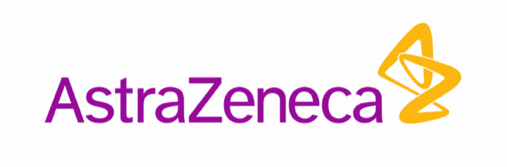







C:\Users\byrne_niki\AppData\Local\Microsoft\Windows\Temporary Internet Files\Content.Outlook\NWWBL5QU\ORION Logo NEW_ (2).jpg

C:\Users\byrne_niki\Documents\Anail\2021 Anail Conference\Company logos\novartis_logo_pos_rgb.png